SAI_MANOGN_WIPRO_TRAINING_BATCH(3)_SATINNDER
DAY – 1 [14-06-24]
- Comparision between Dual Core Vs Quad Core?
Dual Core :-  processors are those processing units that have two cores. A core is like a processing part that can complete a single time at a point in time so dual-core means that processing can be done at a faster rate. Dual-core processing systems allow performing more than one function at a time. | Quad Core :-  It consists of 4 cores which give the ability to perform multiple jobs concurrently.
The performance of dual-core processing systems is good.  Not good for tasks like video editing or animations. | Resource utilization is more as compared to dual-core because the number of cores is more.
The hardware of these processors does not get heated as they produce little heat. | It is much faster than dual-core systems and computational efficiency is high.
The graphic support of the dual-core system is weak and it cannot run heavy graphics. | It has 4 cores which give it the capability of parallel computing.
Parallel processing capability is not available in these processors. | The graphic support of the quad-core system is high and it is used to run heavy graphics.
The clock speed and computation capability are slower than Quad-core. | Heat ejection is high and due to this, these processors make the hardware gets heated
Resource-efficient as it uses less power as compared to Quad-core systems. | The performance of dual-core processing systems is better.
It consists of 2 cores, each designated to perform a specific task. | Easily handles the task of video editing and animations.

- Comparision between I3 Vs I7 ?

I5:-  Number of Cores – 4 | I7:-  Number of Cores - 4
Clock Speed Range (Several Models) – 2.4GHz-3.8GHz | Clock Speed Range (Several Models) – 2.9GHz-4.2GHz
Turbo Boost – Yes | Turbo Boost - Yes
Cache Memory – 4-6MB | Cache Memory – 8MB
Hyper-Threading – No | Hyper-Threading - Yes

DAY-2 --- 17.06.24

- ASCII Code for arrows up,down,right,left?
Left Arrow | ← | U+02190
Up Arrow | ↑ | U+02191
Right Arrow | → | U+02192
Down Arrow | ↓ | U+02193

- IP address from /11 to /32?
/8 – 255.0.0.0
/9 – 255.128.0.0
/10 – 255.192.0.0
/11 - 255.224.0.0
/12 - 255.240.0.0
/13 - 255.248.0.0
/14 -255.252.0.0
/15 -255.254.0.0
/16 - 255.255.0.0
/17 - 255.255.128.0
/18 - 255.255.192.0
/19 - 255.255.224.0
/20 - 255.255.240.0
/21 - 255.255.248.0
/22 - 255.255.252.0
/23 - 255.255.254.0
/24 - 255.255.255.0
/25 - 255.255.255.128
/26 - 255.255.255.192
/27 - 255.255.255.224
/28 - 255.255.255.240
/29 - 255.255.255.248
/30 - 255.255.255.252
/31 - 255.255.255.254
/32 - 255.255.255.255

- What is the subnet mask and network address for ip – 70.49.72.1?

subnet mask – 255.255.255.0
Network address – 70.49.72.0

- Answer the following questions?
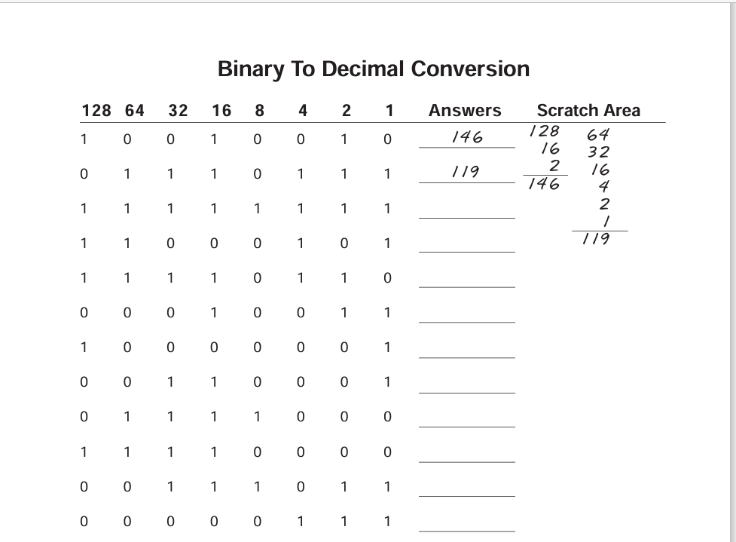

→ 3 – 255
4 – 197
5 – 246
6 – 19
7 – 129
8 – 49
9 – 120
10 – 240
11 – 59
12 - 7
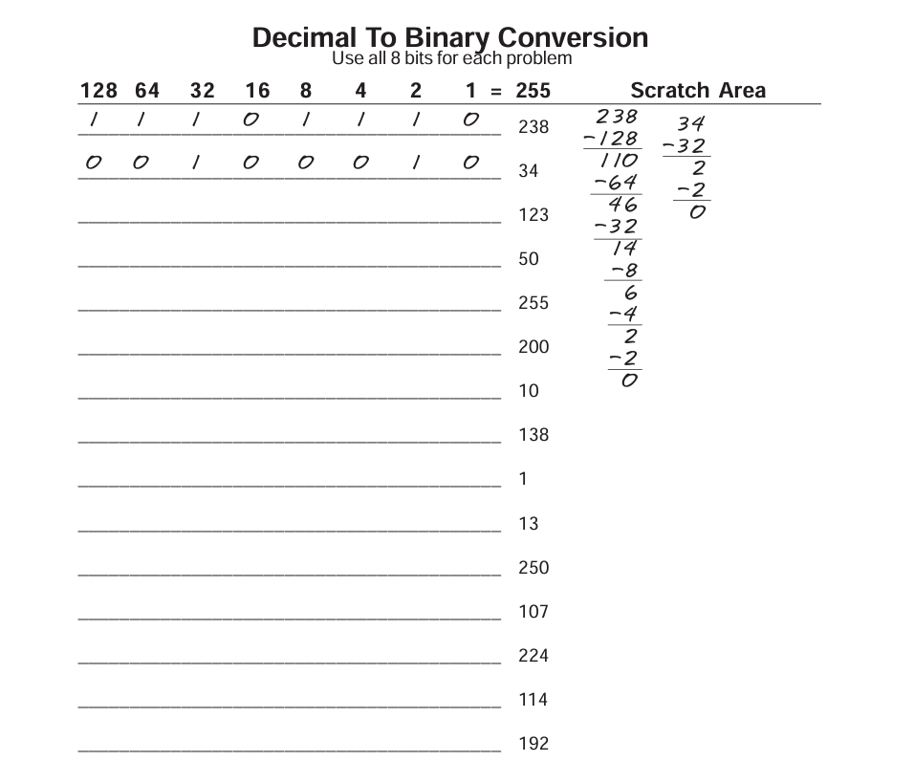

→ 3 – 01111011
4 – 00110010
5 – 11111111
6 – 11001000
7 – 00001010
8 – 01001010
9 – 00000001
10 – 00001101
11 – 11111010
12 – 01101011
13 – 11100000
14 – 01110010
15 - 11000000
-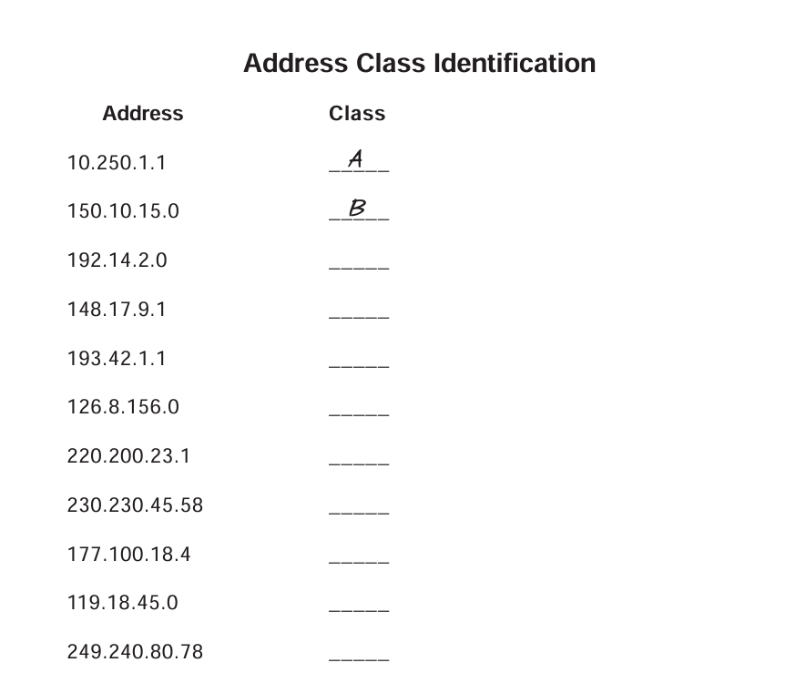
→ Class A: 1.0.0.0 to 127.255.255.255
Class B: 128.0.0.0 to 191.255.255.255
Class C: 192.0.0.0 to 223.255.255.255
Class D: 224.0.0.0 to 239.255.255.255
Class E: 240.0.0.0 to 255.255.255.255

- 3 – C
4 – B
5 – C
6 - A
7- C
8 – D
9 – B
10 – A
11 – E
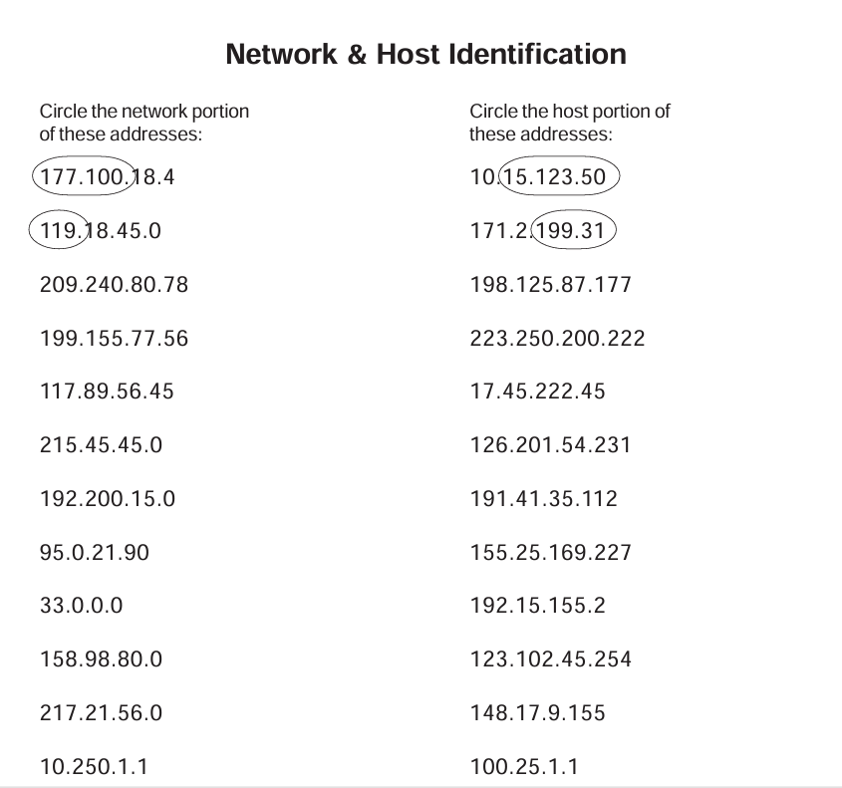
209.240.80 – network address 177 – host address
199.240.80 - network address 222 – host address
177.89 - network address 45.222.45 - host address
215.45.45 - network address 201.54.231 - host address
192.200.15 - network address 35.112 - host address
95 - network address 169.227 - host address
33 - network address 2 - host address
158.98 - network address 102.45.254 - host address
217.21.56 - network address 9.155 - host address
10 - network address 25.1.1 - host address

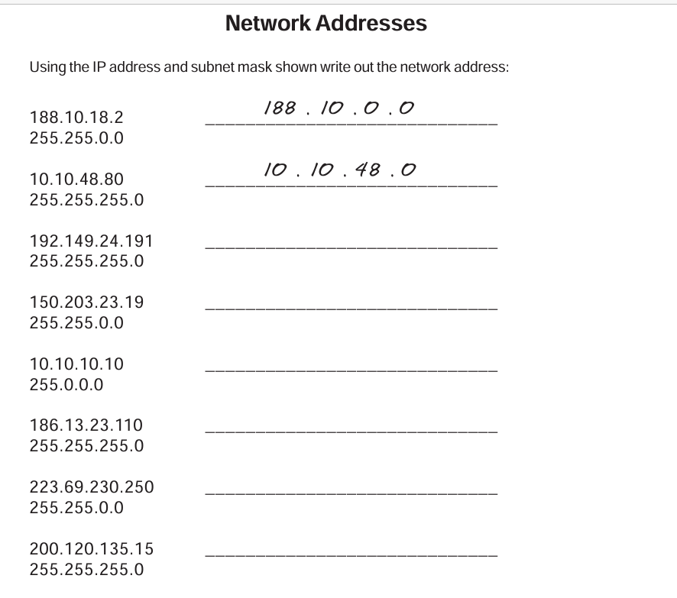

→ 3 - 192.149.24.0
4 - 150.203.0.0
5 - 10.0.0.0
6 - 186.13.23.0
7 - 223.69.0.0
8 - 200.120.135.0

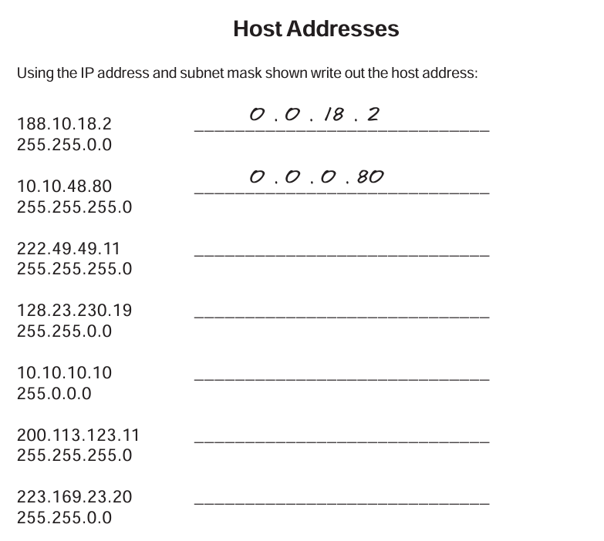

→ 3 – 0.0.18.2
4 – 0.0.0.80
5 – 0.0.0.11
6 - 0.0.230.19
7 – 0.10.10.10
8 – 0.0.0.11
9 – 0.0.23.20

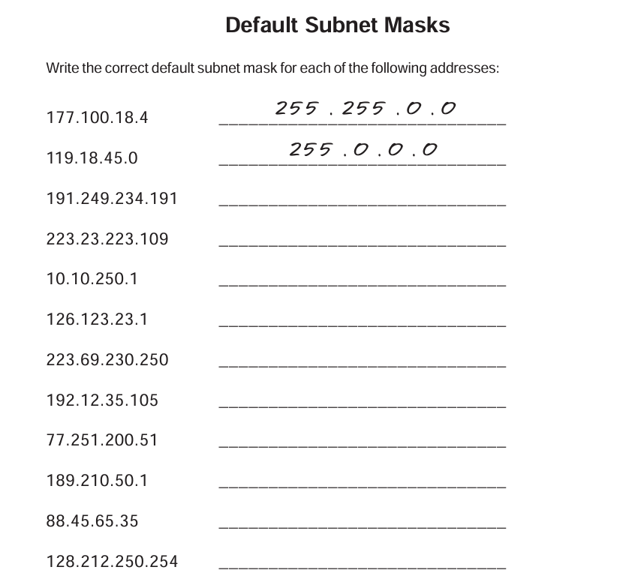

- Default Subnet Masks are
Class A | 255.0.0.0
Class B | 255.255.0.0
Class C | 255.255.255.0

3 – (Class B) 255.255.0.0
4 – (Class C)255.255.255.0
5 – (Class A)255.0.0.0
6 – 255.0.0.0
7 – 255.255.255.0
8 – 255.255.255.0
9 – 255.0.0.0
10 – 255.255.0.0
11 – 255.0.0.0
12 – 255.255.0.0

DAY-3 [18.06.24]
- Connect two routers
- Connect Router with a Switch
- Connect Router with PC
- Connect PC with a switch

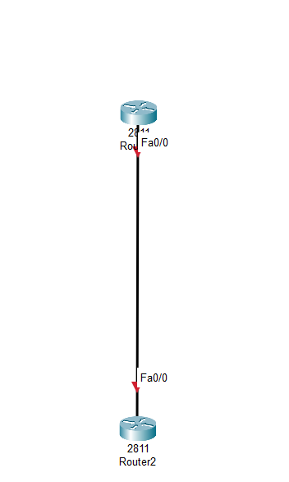

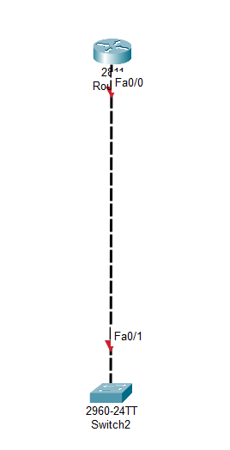

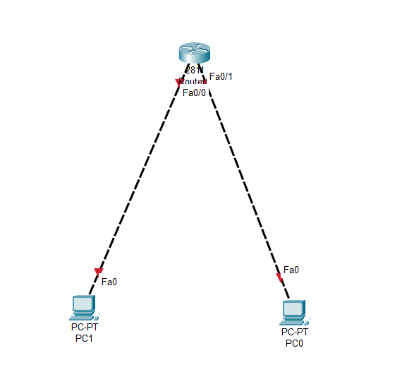

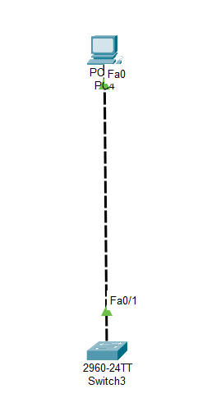
Connect router with PC by adding IP address:-

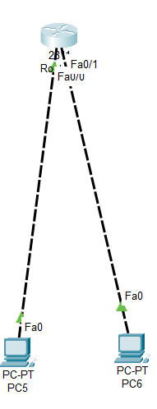
PC – 2 Command prompt
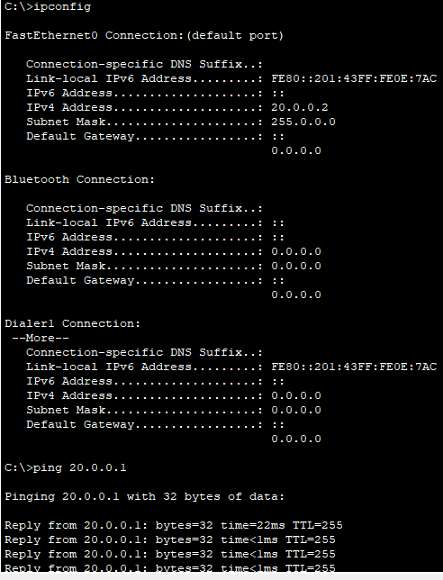

PC – 1 Command promnt
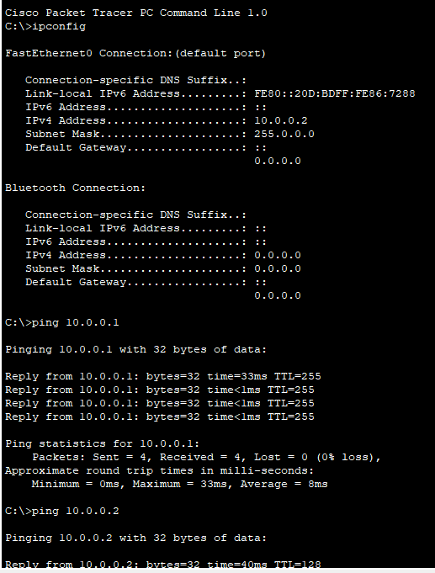

Connect Router to PC through switch by giving IP address:-

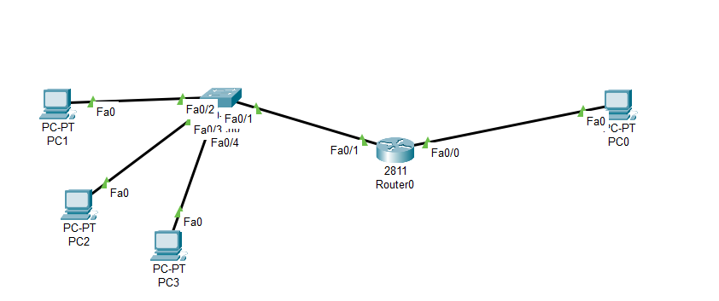
IP address are
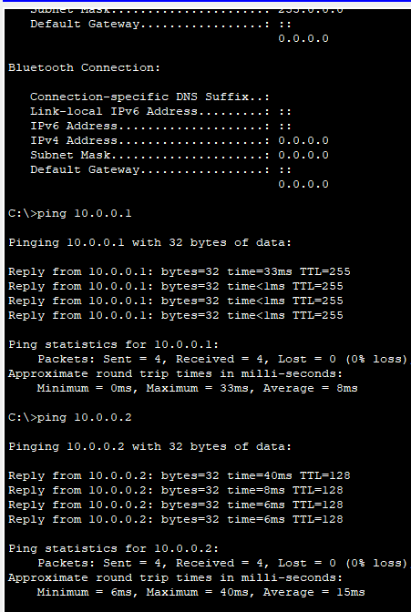
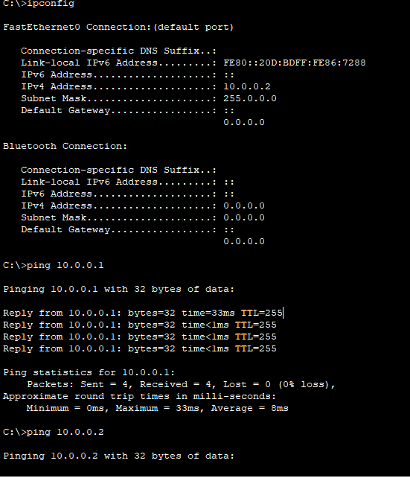
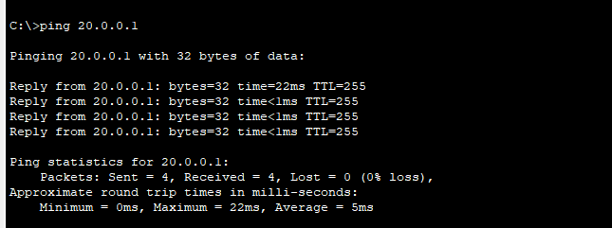

Connection | R1- F0/0 | R1- F0/1
PC-0 | Connected | Connected
PC-1 | Connected | Connected
PC-3 | Connected | Connected
PC-4 | Connected | Connected

Connect 2 Routers with PC through switch by giving IP address:-
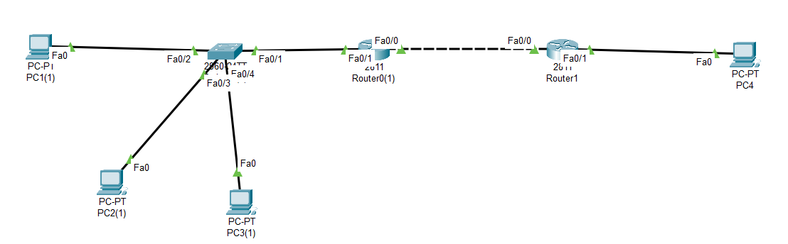
IP adress are :
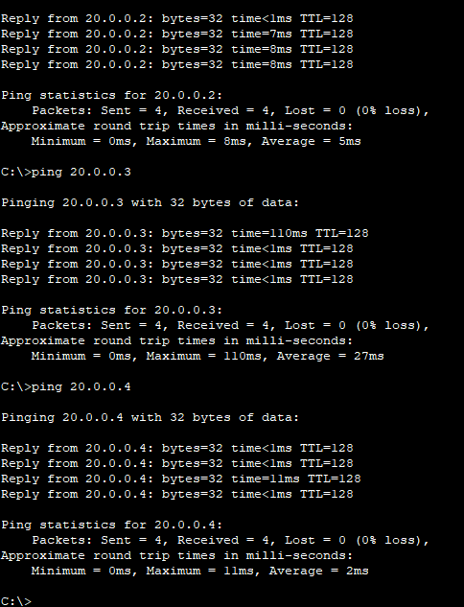
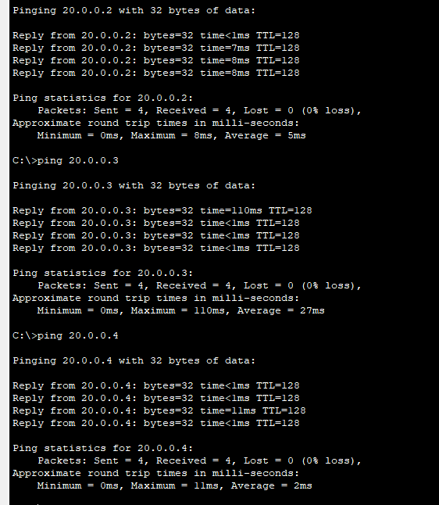
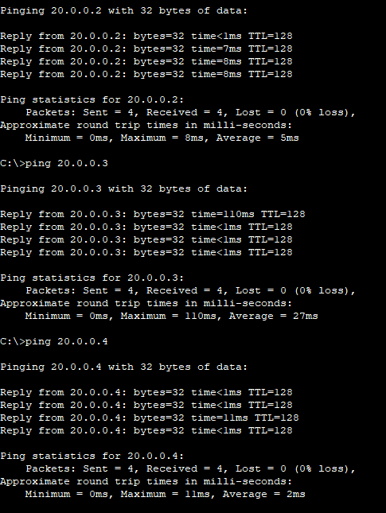

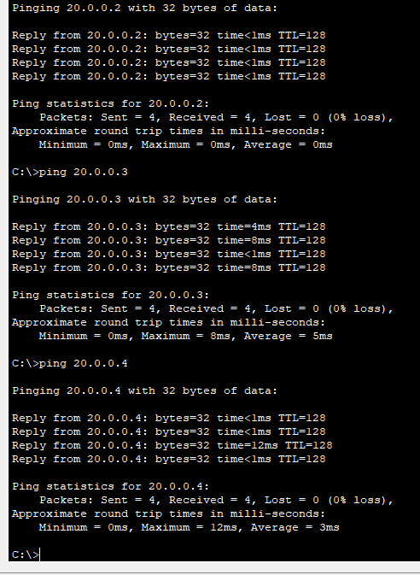

Connection | R0(1)- F0/0 | R0(1)-F0/1 | R1-F0/0 | R1-F0/1
PC-1(1) | Connected | Connected | Not Connected | Not Connected
PC-2(1) | Connected | Connected | Not Connected | Not Connected
PC-3(1) | Connected | Connected | Not Connected | Not Connected
PC-4 | Not Connected | Not Connected | Connected | Connected

Connect 2 PC’s with 2 Routers by giving IP address:-
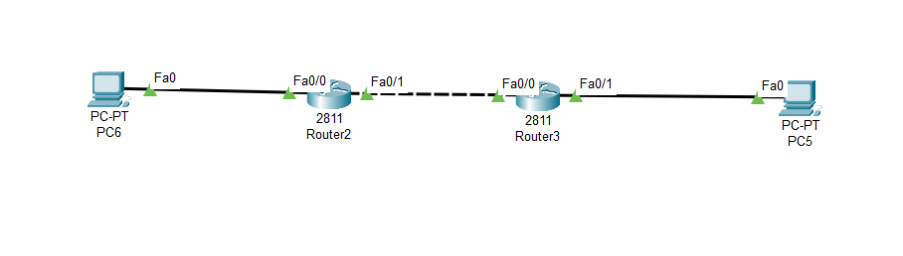
IP address
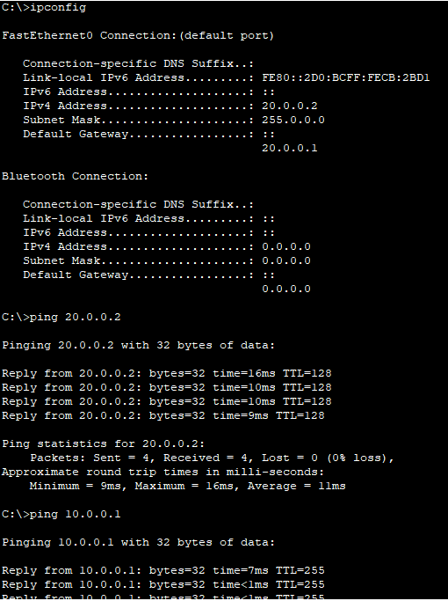

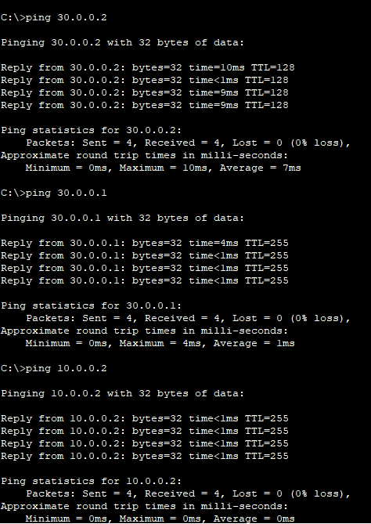

Connection | R2 - F0/0 | R2 - F0/1 | R3 - F0/0 | R3 – F0/1
PC – 5 | Not Connected | Not Connected | Connected | Connected
PC – 6 | Connected | Connected | Not Connected | Not Connected

Day – 4 [19.06.24]
Adding Routing to the Routers:-

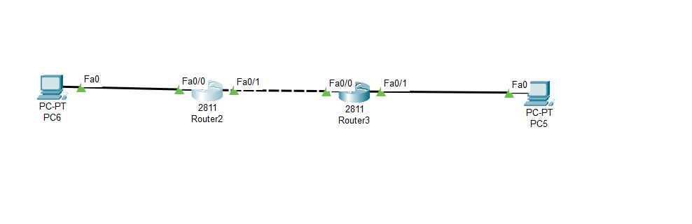
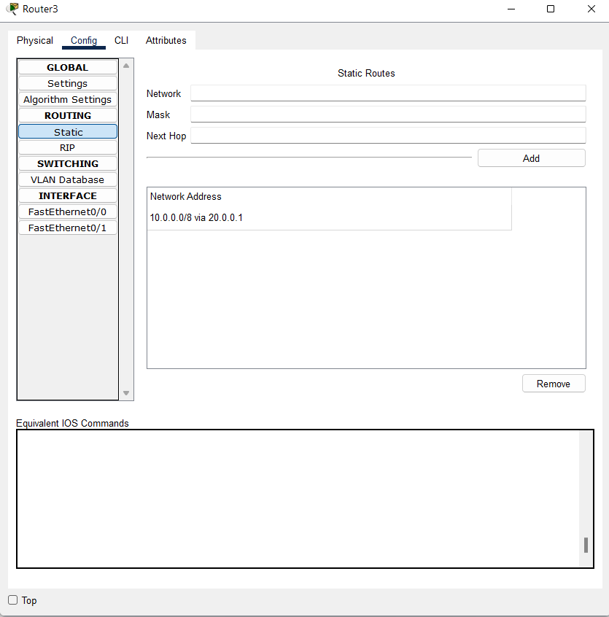

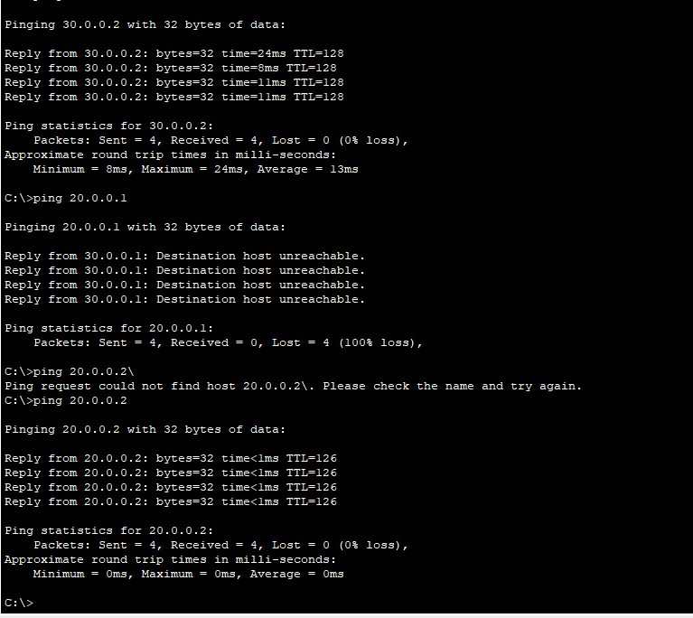
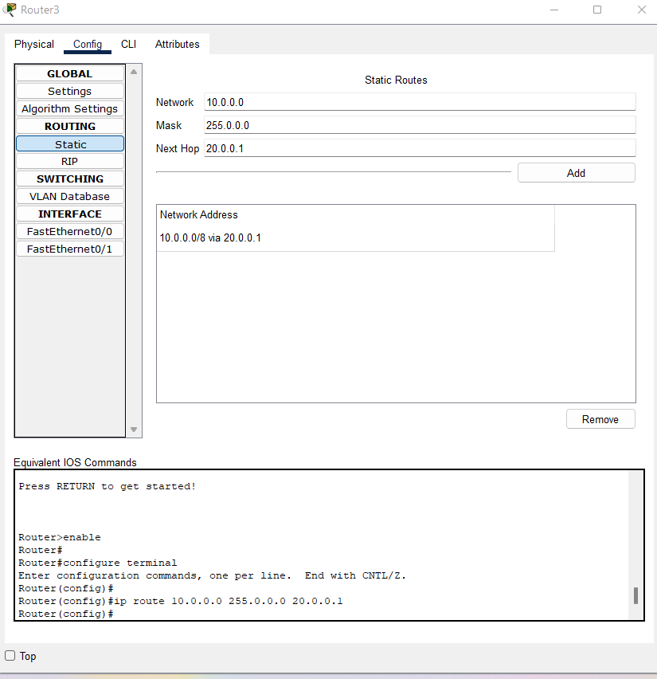

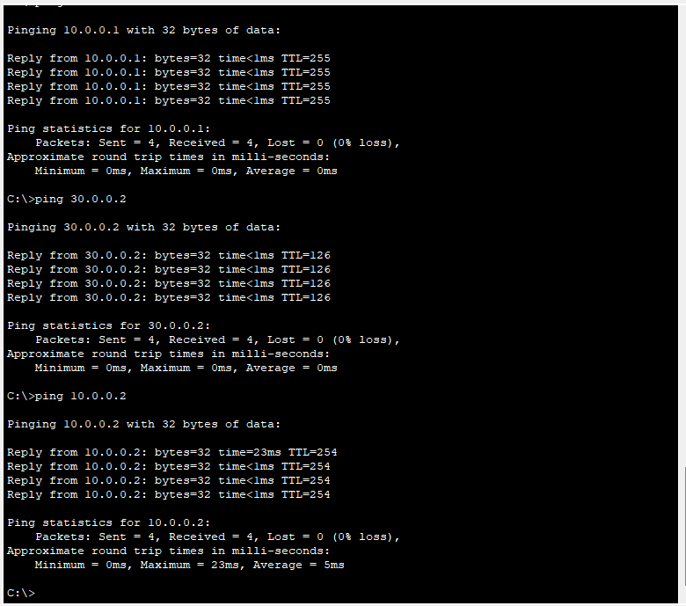

Day – 5 [20.0.6.24]
OSI Model:-
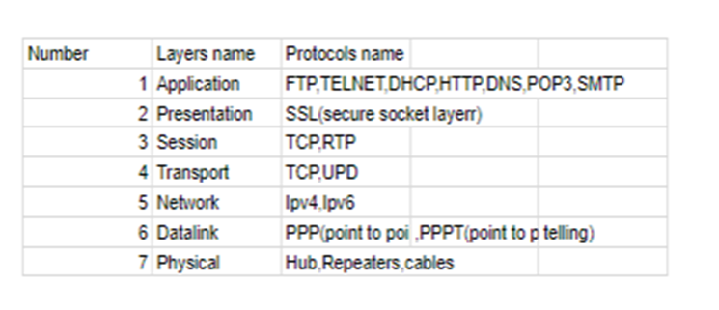
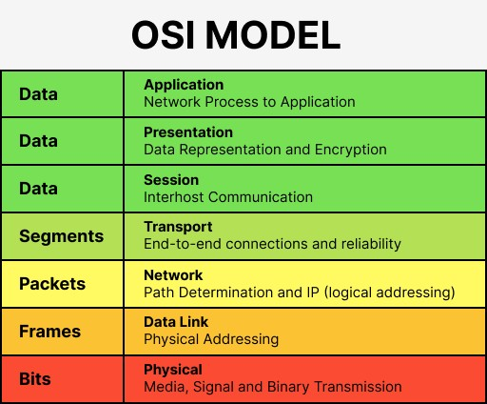

OSI Model Vs TCP/IP:-

 | OSI Model | TCP/IP Model
Full Form | OSI stands for Open Systems Interconnection. | TCP/IP stands for Transmission Control Protocol/Internet Protocol.
Layers | It has 7 layers.  →Application  →Presentation  →Session  →Transport  →Network  →Datalink  →Physical | It has 5 layers.  →Application  →Transport  →Network  →Datalink  →Physical
Usage | It is low in usage. | It is mostly used.
Approach | It is vertically approached. | It is horizontally approached.
Delivery | Delivery of the package is guaranteed in OSI Model. | Delivery of the package is not guaranteed in TCP/IP Model.
Replacement | Replacement of tools and changes can easily be done in this model. | Replacing the tools is not easy as it is in OSI Model.
Reliability | It is less reliable than TCP/IP Model. | It is more reliable than OSI Model.

7 Layer services and port numbers?

Layers | Protocols | Port Numbers | services
Application | HTTP,FTP, SMTP,POP3, IMAP, Telnet | HTTP (80), HTTPS (443), FTP (20, 21), SMTP (25), POP3 (110), IMAP (143), Telnet (23) | Email, web browsing, file transfer, remote login
Presentation | SSL/TLS, ASCII, JPEG, GIF, PNG | SSL/TLS (443), ASCII (7) | Data encryption, data compression, data formatting
Session | NetBIOS, PPTP, RPC | NetBIOS (137-139), PPTP (1723), RPC (Remote Procedure Call) | Session management, dialog control, synchronization
Transport | TCP, UDP | TCP-HTTP (80), HTTPS (443), FTP (20, 21), SMTP(25),POP3(110), IMAP (143),SSH(22), Telnet(23)  UDP-DNS(53),DHCP(67,68),SNMP(161), TFTP(69),NTP(123) | Reliable data delivery, error-checking, flow control
Network | IP, ICMP, ARP | ICMP (Internet Control Message Protocol), ARP (Address Resolution Protocol) | Logical addressing, routing, traffic control
Data Link | Ethernet, PPP, HDLC, LLC | ---------------- | Error detection and correction, framing
Physical | Ethernet, Wi-Fi, Fiber optics, USB, Bluetooth | -------------------- | Physical transmission of data

Using NAT for routers

